Pāhoa Town Center Design Guidelines
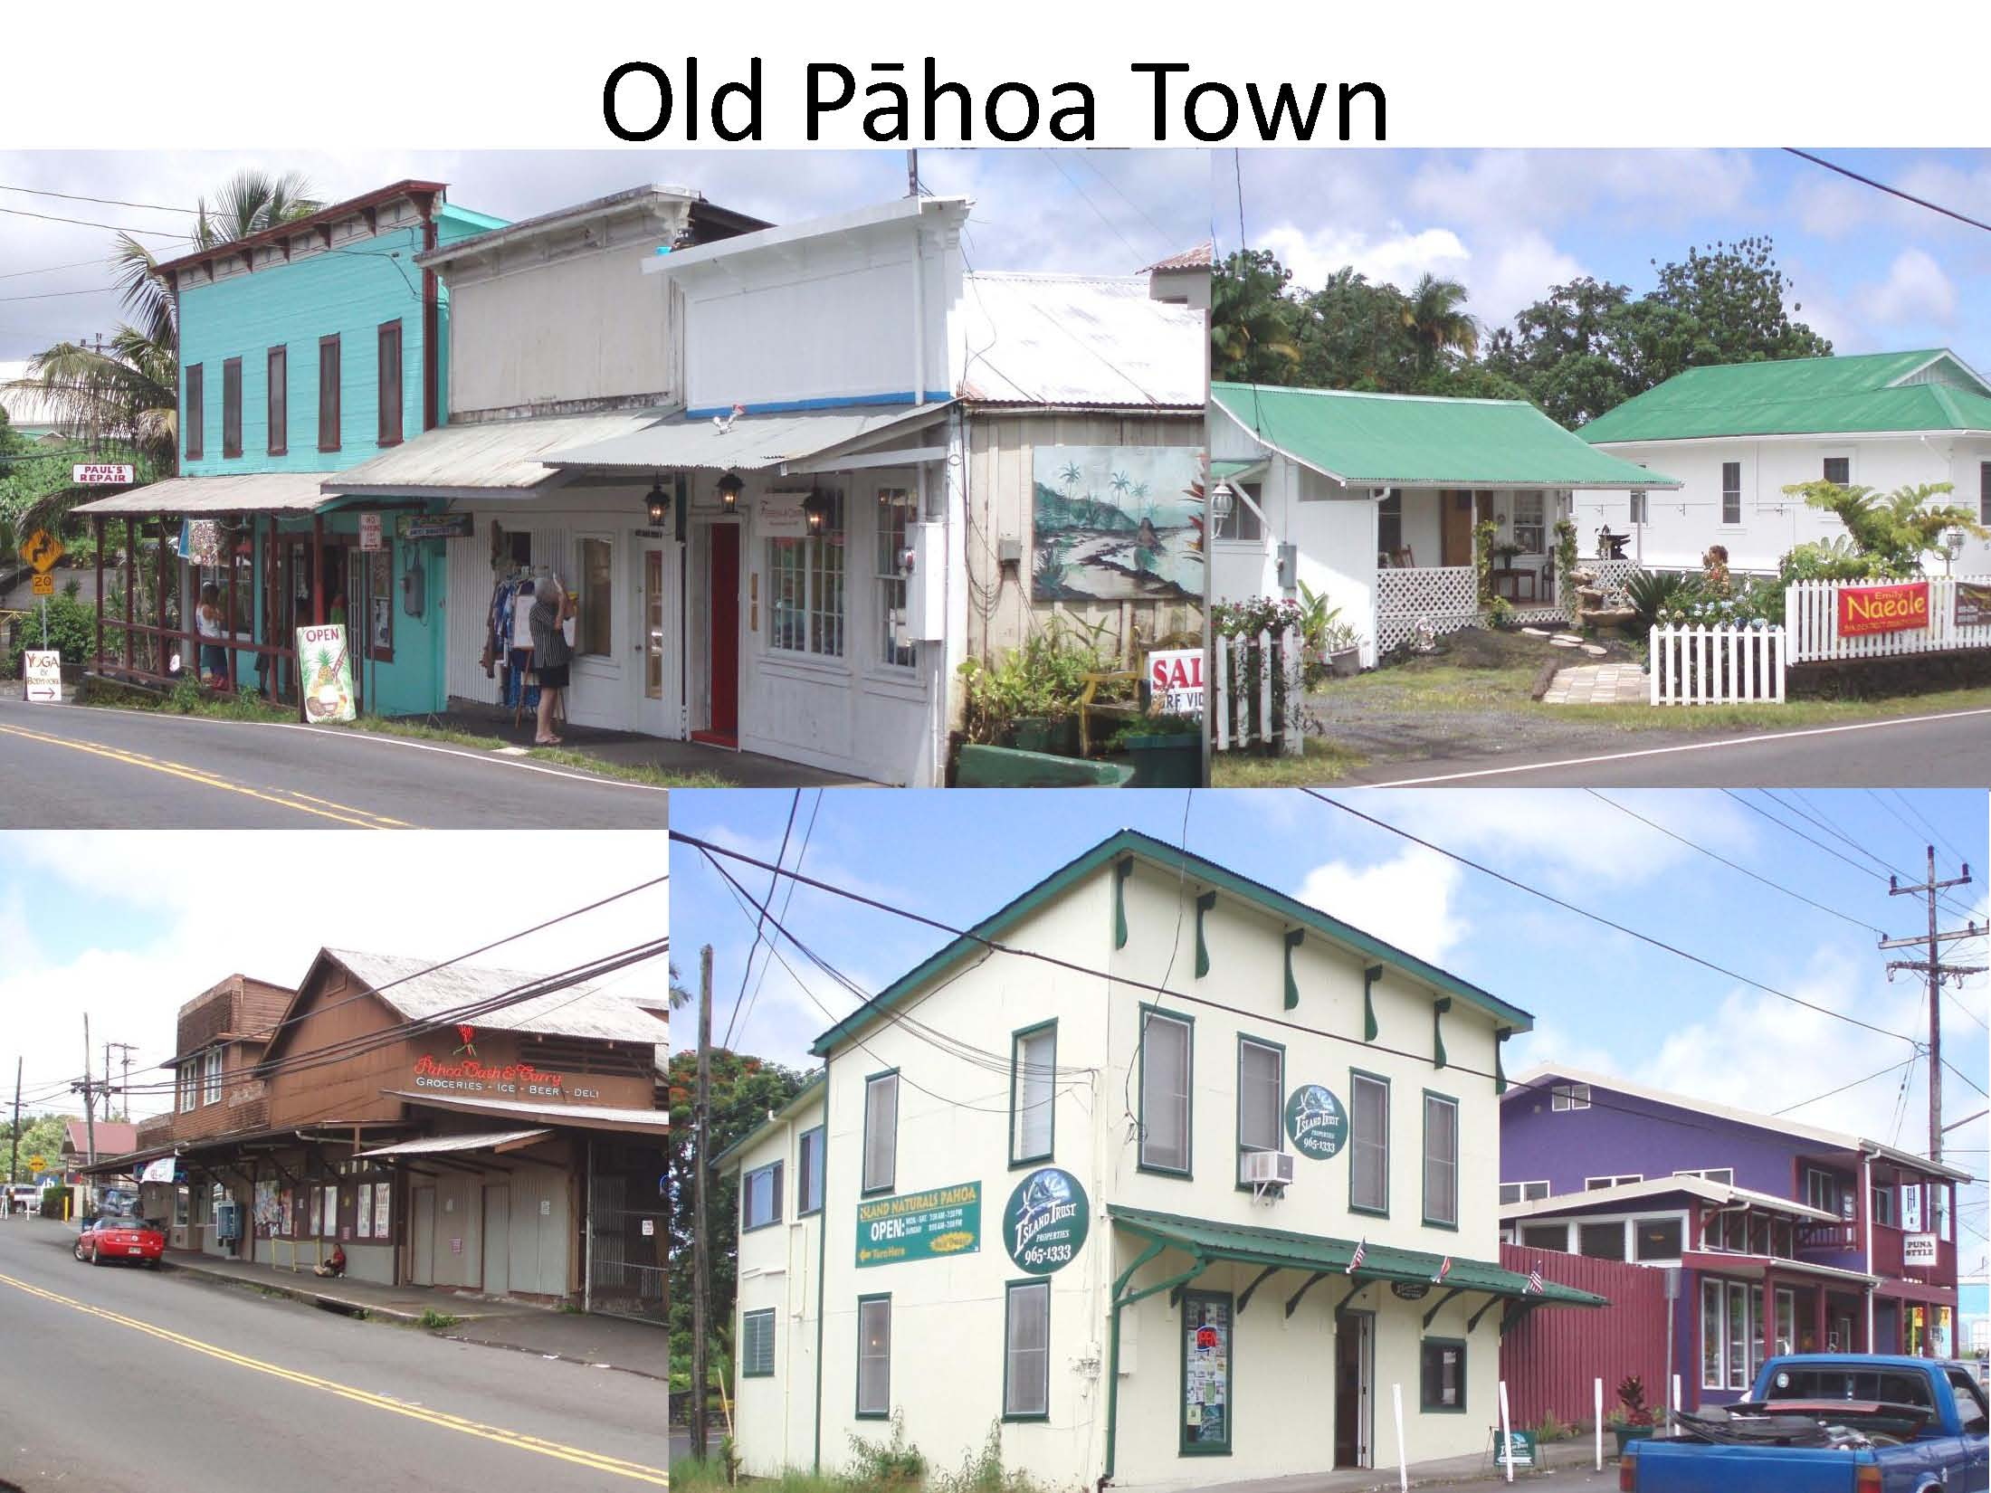

“Place is more than just a location on a map. A sense of place is a unique collection of qualities and characteristics – visual, cultural, social, and environmental – that provide meaning to a location. Sense of place is what makes one city or town different from another, but sense of place is also what makes our physical surroundings worth caring about.”

Table of Contents
Summary of Purpose 3
What you need to know 3
How to get design approval 3
History of Pāhoa 4
Existing Character 5
Character defining features of plantation-style commercial architecture: 5
Character defining features of plantation-style residential architecture: 6
Design Guideline Goals 7
General Design Recommendations 7
Features to Enhance 7
Design District 8
Architectural Guidelines-Commercial 9
Scale 9
Setback 10
Roofs 11
Facades 12
Canopies 12
Walls and Wall Finish 13
Architectural Details 13
The decorative details of shape, color and texture 13
Doors 15
Color 15
Signs 16
Landscape Planting 16
Walls and Fences 16
Parking 17
Architectural Guidelines – Residential 17
Setbacks 17
Building Form, Height and Scale 17
Roofs 17
Walls 18
Windows 18
Doors 18
Design Review Committee 19

Summary of Purpose
The Pāhoa Town Center Design Working Group has attempted to embrace this proposition of “Place” in part by utilizing the unique characteristics of Pāhoa and present this collection of guidelines to create a positive village design environment for daily life and commerce. The guidelines identify the underlying design principles that define Pāhoa’s unique historic and architectural character. The design standards will help preserve Pāhoa’s historic character, allow for new development that compliments and are comparable to Pāhoa’s historical character and will improve the streetscape to make Pāhoa a more pedestrian friendly environment.

What you need to know
The Pāhoa design guidelines apply to all permitted renovations and new developments within the Pāhoa Design District (PDD) (see Figure 1). Pāhoa features a diverse style of architectural styles from various periods of history. These guidelines focus on the dominant architectural styles that influence and define Pāhoa. The intent of these guidelines is to complement Pāhoa’s positive features and encourage development designs that are compatible with Pāhoa’s traditional character. The long term goals are to maintain Pāhoa’s architectural heritage while allowing for new development that is compatible to our goal of creating a sense of Place. To meet these goals, the guidelines promote:
- Renovation of buildings that contribute to Pāhoa’s architectural heritage is strongly recommended.
- For new buildings developers should follow the design elements that are discussed in this section.
- These guidelines allow for the interpretation of traditional building styles.
- The exact replication of historic buildings is not encouraged or appropriate.

How to get design approval
The Pāhoa Design District guidelines are not intended to be prohibitively restrictive, but instead to provide architects, developers and owners with ideas that encourage creative, functional and economical advantageous design for existing and new buildings within the Pāhoa Design District.

For any project within the Pāhoa Design District (PDD) requiring Plan Approval under the Hawaiʻi County Zoning Code, the applicant is encouraged to submit project plans to the Pāhoa Design Review Committee (PDRC) for review and comment prior to submitting an application for Plan Approval to the Planning Department. In cases where project plans are submitted to the PDRC via the Planning Department after an application for Plan Approval has been submitted to the Planning Department, the PDRC review will be consistent with the time frame provided in the Zoning Code (Chapter 25, Article 2, Division 7, HCC).

Although not required, applicants are encouraged to submit project plans for residential and other projects that do not require Plan Approval by the Planning Department to the PDRC for review and comment prior to submitting an application for a Building Permit from the County of Hawaiʻi. Failure to secure PDRC comments for any residential or other project that does not require Plan Approval shall not prohibit the issuance of a Building Permit by the County of Hawaiʻi.

The project plans submitted to the PDRC shall include the following:
- A site plan, drawn to scale, showing all existing and proposed improvements, parking, and landscaping;
- Exterior elevation drawings;
- Description of exterior siding, roofing and finish materials;
- Exterior door and window specifications; and
- Description and renderings for any exterior signage.

The Pāhoa Design District Guidelines are subject to applicable existing regulatory controls. Where any conflict arises between the zoning regulations and these design guidelines, the more restrictive provisions will prevail.

History of Pāhoa
It is believed that the general area of Pāhoa was first developed around the mid 1880’s, prior to that it was a lush tropical lowland rainforest. This tropical rain forest and its by-products provided an environment that was the reason for the first wave of immigration. The immigrants required housing and services and this catalyst was the beginning of development of the town of Pāhoa.

The first Sugar Plantation in the area was started in 1900 as the Puna Sugar Company and later became the Ola’a Sugar Company the company outlasted all others, ending its operations in 1984. In what is now the center of Pāhoa Town the first lumber mill was erected in 1907 and was named the Mahogany Lumber Company, which stayed in business until 1918. The company supplied all the timber for the town construction as well as exporting over millions of railroad ties for the construction of the various railroads in the Southwestern United States and for the ties for the Sugar Plantation railroads. In 1908 the Pacific Rubber Company was created and planted over 160 acres of rubber trees. They ceased operations in 1921.

The majority of the early residents were Japanese immigrants who came to Hawaii on a 3 year worker’s contract. Those few who decided to stay after their 3 year contract expired and had managed to save enough money, built simple wood houses on stilts with wide lanais, gabled style, metal clad roofs and redwood catchment systems located at the back of the lot. The rest of the immigrants lived in 6 Camps provided by the lumber mill. Virtually all the buildings along the main town road in the early 1900’s housed some type of business offering from shoe repair to hotel lodging.

There was very little private land ownership in the early years as the majority of the land was owned by the Roman Catholic Mission, the Lumber Mill and the Territory of Hawaii so most of the land was leased. When land ownership finally became available in the late 1930’s the lots were very small to several acres and haphazardly laid out as there was no such thing as land planning. Electrical power did not come to Pāhoa until 1938 and domestic water in 1962.

Existing Character
Most of Pāhoa's older commercial and residential buildings are characterized as "plantation style" and are typical of buildings commonly seen throughout Hawaii's small towns. Vernacular plantation-style building features vary, but generally share the following characteristics:
- Building height: usually two stories in height, or some one-story structures with false-fronts nearly as high as two-story buildings.
- Setback: no setback from property lines and the sidewalk.
- Roof form: gable, shed, or flat roof, often behind a false front.
- Roof materials: typically corrugated metal, sometimes tarpaper; later composition shingles were used.
- Walls: single-wall construction primarily of vertical tongue-and-groove board, board and batten or horizontal boards.
- Storefront: Small, irregular and varied.
- Entries: Often flush with the front wall, occasionally recessed to provide shade and shelter for pedestrians.
- Doors: Wood and wood-with-glass doors featuring multiple panels, raised panels, or glazing and panels.
- Windows: Multiple-light and wood framed, with wood sashes and mullions, double-hung windows double hung windows featuring transoms.

Character defining features of plantation-style commercial architecture:
False-front facade: Hawaii's plantation-style commercial architecture typically featured
a false front because building materials were quite expensive in relation to the labor
costs. Architectural ornamentation was often limited to the building's facade and resulted in numerous variations of the false front.

Canopy: Canopies across the main façade are a character-defining feature in plantation style commercial structures. Most canopies were shed roofs covered with corrugated metal. A few of Pāhoa's canopies were hipped with shingles. Most canopies were supported by brackets underneath and/or rods above; posts were sometimes used to support canopies in turn-of-the-century structures. Historically, some of Pāhoa’s two-story edifices had wood-framed balconies, which also functioned as canopies. Canopies and balconies provide the shade and weather protection important in a pedestrian-friendly environment. Unfortunately, many canopies have been removed from Pāhoa's historic buildings due to deterioration ₁ or the requirements of modern building codes.

Cornice: Often used in plantation-style commercial architecture, cornices were sometimes ornamented with rather elaborate brackets, while others were quite simple in detail. Cornices and brackets were an easy way to decorate a building during an age when craftsmen were easy to find, but building materials were not.

Attic Vent: Louvered attic vents were a prominent, distinctive feature of plantation architecture, often appearing in a variety of geometric shapes, including round, square, rectangular, semi-circular, and rectangular with a gable-shaped peak.

Kick plate: Older plantation-style buildings often included an architectural feature known as a "kick plate." Kick plates are wood panels located beneath the windows and approximately 18" above the foundation. Many of Pāhoa's plantation-style buildings have been inappropriately remodeled with large plate-glass windows that replaced both the historic windows and kick plates.

Character defining features of plantation-style residential architecture:
Most of Pāhoa’s older residential buildings are characterized as "plantation style" and are typical of older houses throughout Hawaii. "Plantation-style" features vary, but generally share the following elements:
Building height: Usually one story.
Foundation: Post and pier
Roof form: Gable, hipped, and gable over hip.
Roof materials: Corrugated metal, wood shakes; in recent decades, many were reroofed with composition shingles.
Walls: Single-wall, vertical-board construction. A prominent feature on plantation style houses is a girt, a horizontal band that wraps around a vertical board house, in essence serving as a girdle that holds the boards together.
Eaves: Open, overhanging eaves with exposed rafters.
Doors: Wood with glass doors or French doors with sidelights.
Windows: Wood-framed, double-hung windows, sliding sash windows, casement windows or more elaborate windows, with diamond or rectangular-patterned panes.
Attic Vent: Louvered attic vents in a variety of geometric shapes, including round, square, rectangular, semi-circular, and rectangular with a gable-shaped peak.
Lanais: Covered with a shed or gable roof often highlighting the entrance; some ran the full width of the house. A simple or decorative balustrade added to the lanai.

Design Guideline Goals
- Encourage high density, small scale building design with historic character.
- Encourage a variety of uses.
- Integrate commercial activity with residential components.
- Create a smooth transition between commercial and residential land use.
- Commercial operations at street level with residential or low volume commercial on upper floors.
- The development of passageways and courtyards where applicable should be created to link nearby streets and parking areas.
- Buildings should be sited with no front or side yard setbacks.
- Plant street trees were feasible or use planter boxes.

General Design Recommendations
The Pāhoa Design Committee has identified certain features that should be incorporated into all new construction and building renovation projects within the Design District.

Features to Enhance
- The traditional downtown's small scale, with its predominantly low-rise, pedestrian-friendly environment. Automobiles and the associated amenities should not be allowed to overwhelm the town.
- The variety of small storefront architectural styles from various eras in Pāhoa's history. Details on historic buildings should be preserved, including traditional canopies, false-front parapets, attic vents, cornices, windows, doors, and other architectural elements.
- Pockets of landscaping and greenery, especially in the commercial blocks.
- Passageways and courtyards between buildings, which link nearby streets to parking areas.
- The mass and scale of new buildings should complement, not overwhelm, Pāhoa's traditional, small-scale architecture.
- Canopies are highly recommended as means to keep Pāhoa pedestrian friendly. Canopies should be replaced and/or restored on Pāhoa's historic structures.
- Landscape all parking lots that have street frontage. Plantings should be of size and caliber to screen automobiles from pedestrian sight lines upon completion. Efforts should be made to include Native Hawaiian Flora whenever possible.
- Improve and/or maintain neglected and vacant lots.
- Plant street trees where feasible.
- Improve sidewalks to adequate ADA compliant widths; build new sidewalks where necessary, especially in areas where sidewalks are not continuous.
- Utility lines should be located underground from the border of the lot line to the connection of the building.

Design District
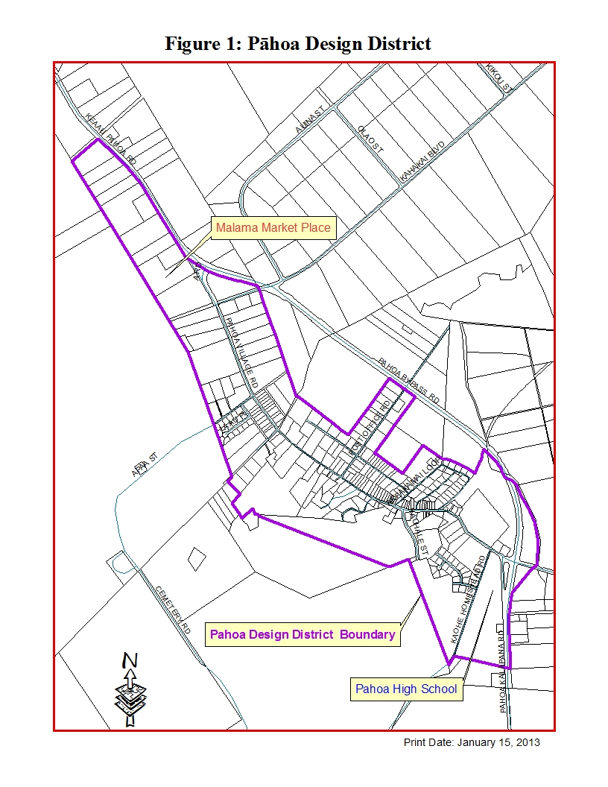
The Design District is defined by those Tax Map Key parcels with frontage along Pāhoa Village Road, Post Office Road, Highway 130, or that are designated medium density urban by the Hawaiʻi General Plan as depicted in Figure 1. The Design District shall be subject to review every 5 years in accordance with the rules to be established for the Pāhoa Design Review Committee. These design guidelines are intended to encourage the development and rehabilitation of this area as a place where residents can live, work, shop and recreate in s lively, aesthetically pleasing and walkable neighborhood. Residential use above storefronts or adjacent to businesses is encouraged.

Architectural Guidelines-Commercial

Scale
Definition: A structure's height is the vertical distance from the average grade around the building to the uppermost portion of the building. Mass is the building's physical size and bulk. Scale is the size of a structure as it appears to the pedestrian. A building's height, mass, and scale define the character of an area and are key considerations in making a structure compatible with its surroundings.

Height, mass, and scale should reflect Pāhoa's traditional architecture: Building height should conform to the limits defined in the Pāhoa Area Zoning Code. New construction should be similar in mass and scale to historic structures.

When a new building is sited adjacent to architecturally or historically significant buildings, the new building facade should be no more than one story higher than the adjacent historic buildings

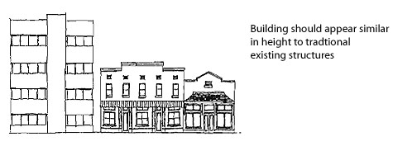

- Stories should not be added to an existing building if the change in scale to the adjacent structures is significant.
- The scale of a neighborhood takes precedence over the scale of an individual structure.
- Abrupt changes in scale are inappropriate.
- No structure or complex should significantly change the overall scale of the neighborhood. The prevalent pedestrian scale of Pāhoa should be maintained.
- Canopies are strongly recommended to reduce a structure's vertical emphasis and encourage a pedestrian environment.
- The contextual scale of large, new buildings can be reduced by using vertical divisions and stepped roof lines.
- Windows, doors, and other architectural details should be used to reduce the apparent mass of larger structures.
- The mass and facades of large new buildings should be divided into several, smaller "storefront" to reduce the building's apparent scale

Setback
Definition: The distance between the building and a reference line, usually a sidewalk or property- line is the setback.

The lack of a setback is a character-defining feature of Pāhoa’s traditional streetscape. It creates a solid architectural edge that defines and unifies the street. Pāhoa’s architectural character is compromised when vacant lots and parking areas interrupt the continuous wall of buildings.
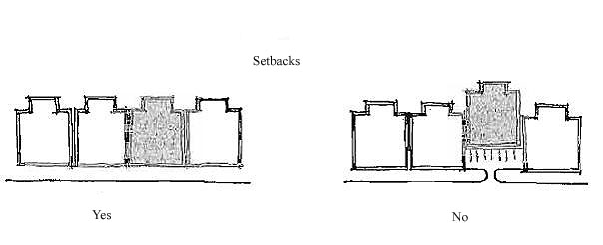
Buildings in commercial areas should a butt the front sidewalk on the street frontage.

Setbacks are measured from the buildings main façade. Canopies, awnings and balconies should not be used in establishing setbacks for reference points.

Canopies, awnings, balconies, eaves, signage and other similar elements may encroach into the required front yard setback and into the public sidewalk right of way.

New Buildings should be sited at the minimum setback per Chapter 25, HCC, except:

- Where a setback is desired, for instance for parking or outdoor seating, the side yard setback along the first fifteen feet of the building depth should be at the minimum setback, with the remainder of either side yard being increased for the desired use.
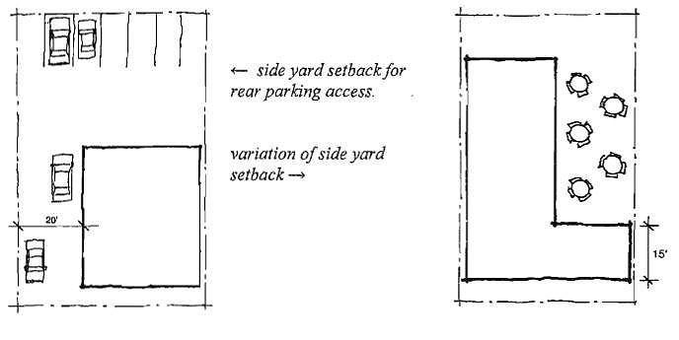

Roofs
In addition to protection from the elements, a roof and its form influence a structure’s architectural character. The predominant roof forms in Pāhoa’s older buildings are a shed or gable roof behind a false front.
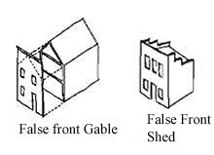
- When renovating existing buildings, the functional and decorative features of the original roof, including the shape, material, color and pattern should be preserved.
- New developments should utilize roof shapes, materials and colors that are compatible with Pāhoa’s traditional architectural character.
- Avoid changing the historic configuration of a roof by adding new features such as dormers, vents or skylights.
- Flat or shed roofs should have a false front that is appropriately scaled for the building. Wood frame or stucco trim should be used for textural details.
- When using formed metal for roofing panels, corrugated metal shapes (rather than standing seam metal) should be installed.
- Mechanical equipment should be shielded from view. Solar collectors, skylights, and other non-historical hardware should not be visible from the street or sidewalk.

Facades
Definition: A façade is the principle exterior face of a building, the architectural front, which is usually distinguished for other faces by elaboration of architectural details.

- Façade design should be compatible with the traditional architectural character of Pāhoa.
- New buildings with end gable roof forms and false fronts are encouraged.
- Canopies and or balconies should extend across the entire building front were applicable.
- Historical architectural elements such as attic/roof vents, paneled kick pates and window transoms are highly recommended for new structures.
- Recessed store fronts are encouraged.
- Glass windows should be at least 18” above the sidewalk level.
- Symmetrical storefront designs are encouraged.
- Architectural details should be incorporated to add interest to and break down the scale of monolithic walls.
- New buildings with a façade over 50 feet wide should use vertical divisions in the facades to create appearances of separate store fronts.
- Utility and mechanical structure should be located away from public view.

Canopies
Definition: a canopy is a roof structure that projects from a building to protect doors, windows and other openings from the elements. Canopies and Balconies are a defining characteristic in Pāhoa’s plantation-style architecture. Canopies enhance the streetscape, help identify store fronts and protect pedestrians from the sun and rain.
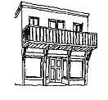
- Original canopies on historic structure should not be removed.
- Canopies and balconies are strongly encouraged along street frontage for all new developments, redevelopments and renovation projects.
- Canopy or balcony design should respect the scale of the surrounding environment.
- Canopies may be pitched or flat.
- Canopies should be supported by metal rods or chains above and wood brackets beneath. Canopies should not be supported by posts within public walkways.
- Canopies should be permanent in nature.
- A second story balcony may function as a canopy
- All balconies should have open balustrades.

Walls and Wall Finish
Wall finish materials not only serve a functional purpose, but can be also used to enhance a building’s design. Traditional walls were tongue and grove boards and to a lesser extent board and batten.
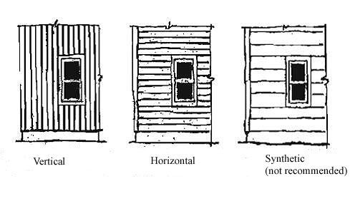
- Original wall materials should be repaired or restored in kind.
- Original historical building materials should not be covered with other finish materials, including, but not limited to: aluminum, vinyl, plastic, asphalt sheets or shingles, brick veneers or plywood.
- Wall finishes should be compatible with the existing character of the buildings in Pāhoa.
- Walls of buildings should have a consistent finish:
- Wood siding should be consistent in a horizontal or vertical direction
- Walls of exposed concrete block or plywood siding (T1-11) should not be used
- Plywood may be used on new construction only if battens are used to create board and batten look.
- Composite siding like Hardy plank and board may be used as long as it has a distinctive wood grain look.

Architectural Details

The decorative details of shape, color and texture
Traditional plantation style architecture reflects an era when building materials were expensive and labor costs were low. Because of this architectural ornamentation and details were limited to the buildings main façade.

- Architectural details should be simple.
- Original architectural details should be preserved on any buildings being rehabilitated.
- Ornamentation from the Plantation era should be incorporated into new construction, including vents, canopies, false fronts, cornices, brackets, transoms, kick plates, doors and windows.
- Details should be well integrated to the design and not appear as “add ons” or after thoughts.
- Design motifs should reflect meaningful symbols or forms from the surrounding environment.
- Trim and pattern relief should be used to break up the monotony on large long structures.
- New construction should not be overly cluttered with ornamentation detail.
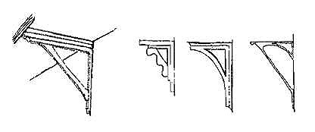
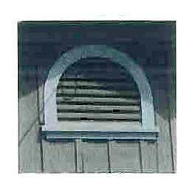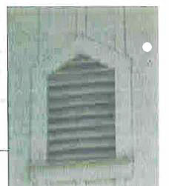
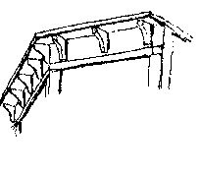

Doors
Doors are often one of the first items to be replaced when a building is modernized. Flush mounted wood doors or aluminum framed glass are typical of modernization.

- Use wood doors and frames. Doors should have featured multiple panels or panels and glazing.
- Whenever possible maintain original door styles and hardware in its original opening wherever possible, especially on the primary façade.
- Door frames of aluminum and vinyl must simulate natural grain materials or be trimmed so as to minimize their non-traditional appearance.
- Flush mounted doors without panels are not permitted.
- For new construction, doors should be compatible with the existing traditional styles.
- Glazing in storefront doors should be proportionate to store front windows.
- Glass panels should not be painted.
- Large size delivery doors, barred metal doors and aluminum doors should not be visible from the street.

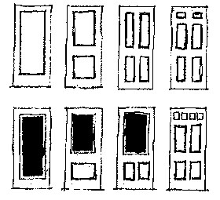

Color
Exterior color is one of the most important aspects of a building. Color is also one of the simplest architectural details to change and can be an excellent method to quickly enhance a building’s appearance and streetscape.

- Dark green, brownish red, white, beige, gray is typical of plantation style coloration.
- Contrasting complimentary colors should be used for accents, trims and architectural details that comprise relative minor portions of the building’s façade. These colors are generally brighter or darker.
- Side and rear walls should be painted in the same colors as the building’s main façade.
- Fluorescent colors should not be used on any structure.

Signs
Signs are an important element of the Pāhoa Design District, providing information and identifying businesses, but also adding interest and a visual variety to the streetscape. While sign diversity is encouraged, individual signs must be compatible with over all character of Pāhoa and the adjacent structures. All signs must conform to Hawai’i County sign ordinance, in addition:

- Sign design should be compatible with a buildings architecture style and colors and should not overwhelm the façade or its architectural details.
- Signage should be compatible with Pāhoa’s existing signage and appropriately located.
- Commercial establishments should have no more than two signs: a hanging/projecting sign and a wall sign.
- Signs should be graphically simple and present an appropriate level of detail without appearing cluttered. Information should be limited to the name and /or nature of business.
- Sign material should be wood or non-reflective metal, on which the design can be carved, sand blasted or painted.
- The following are prohibited: Flashing, blinking, rotating, plastic, or inflatable, roof and detached freestanding signs.
- Use shielded or indirect external lighting to illuminate signs.

Landscape Planting
- All landscaping should conform to Planning Department Rule 17 a.
- Landscaping should be used to enhance and compliment the adjacent building architecture, but should not hide a building.
- Landscaping should be used to encourage pedestrian circulation by providing visual variety, color and shade.
- Parking lots should be landscaped with canopy shade trees and screened by hedges, walls or fences from public view and adjacent buildings.
- All open storage should be screened from public view by landscaping a fence or a wall.

Walls and Fences
Walls and Fences provide enclosure, definition and privacy, but can also serve to compliment a structures architectural feature.

- Fence and wall materials should be compatible with a building’s architecture and the overall character of the area.
- Walls and fences along a public right-of-way and/or front yard should have a maximum height of 3 feet. Corners and intermediate posts and pillars may be six inches taller.
- Chain link fences are not permitted along lot frontage, adjacent to public open space, or in any area readily visible to the public.
- Side and rear yard walls and/or fences that are readily visible to the public should utilize landscaping to screen any portion visible to the public.

Parking
- On-site parking should be located at the rear of a building in order to minimize negative visual impacts.
- Avoid parking areas at the sides of buildings that separate building facades on the adjacent lots.
- Parking areas should be screened from the street with landscaping, walls, and/or fences.
- Parking entrances should be designed to minimize interruptions in street tree patterns and the number of curb cuts.
- Rooftop parking should be screened from public view by architectural features such as false fronts.
- For smaller lots where on-site parking is not practical, Hawaii County should consider waiving parking requirements and instead implement and assessment fee that could be used to fund public parking lots.

Architectural Guidelines – Residential

Setbacks
Historically, residential buildings were set back from the sidewalk or street and featured a front yard. In addition to a main house, some lots also included smaller secondary structures such as cottages, garages, carports and storage sheds.

Building Form, Height and Scale
New homes should respect and maintain the building mass and form of Pāhoa’s traditionally small forms
- Typical houses were one story and featured a simple geometric shape. No structure should sharply contrast with the overall scale of the neighborhood
- Primary dwelling structures height shall be consistent with the Hawai’i County code.

Roofs
New homes should utilize roof shapes, materials and colors that are compatible with the existing traditional architecture of Pāhoa Town.

- Gable, hipped and gable-on hip roofs were traditional forms. Hawaiian hipped roofs with flared eaves are also evident in Pāhoa and are considered appropriate for new residential construction.
- Many plantation-style homes had toe tongued corrugated roofs. Traditional roof materials also include wood shakes and asphalt.
- Roof colors should be of earth tones. Reflective surfaces and shiny or bright colors should be avoided.
- Mechanical equipment should be installed or concealed from public view. Solar collectors, antenna, and there supporting hardware should not be visible from the public street.

Walls
Wall finishes should be compatible with the traditional character of existing buildings in the Design District.

- Builders are encouraged to construct houses with traditional materials including vertical board, board and batten and horizontal board. Imitation wood materials such as “Hardy Plank or board” or its equivalent are acceptable.
- Girts, a horizontal band encircling a house at mid-wall, were a common feature and can be used as a distinctive plantation-style detail.
- To preserve the historic integrity of Pāhoa’s older homes, original building materials should not be covered with finish materials such as aluminum, vinyl, plastic, asphalt sheets or shingles, brick veneers, plywood sheets. Imitation wood materials such as “Hardy Plank or board” or its equivalent are acceptable.

Windows
The windows in the traditional plantation style homes served a functional purpose, but were also a character-defining feature.

- The predominant window style was wood framed, double hung windows, often with multiple-lights.
- Wood framed, multiple panes, sliding sash windows were also quite common.
- Wood framed casement windows were also used.
- Homes of more upscale design had more elaborate windows with diamond or rectangular-patterned lights.
- Aluminum is inappropriate. If synthetic materials are used they must have some type of simulated wood grain pattern or be trimmed so as to minimize their non-traditional appearance.

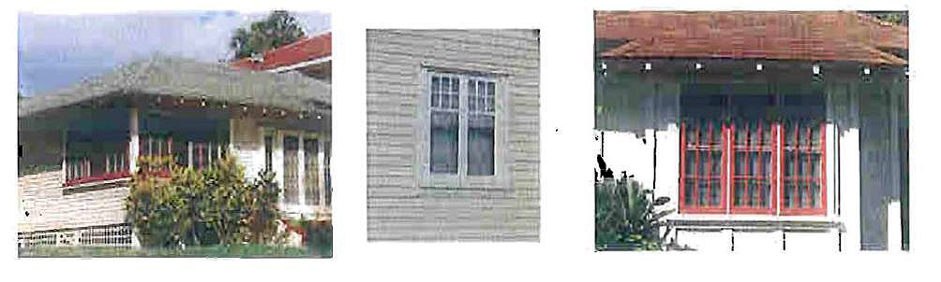

Doors
Doors, like windows, were often a key element in the design aesthetic of plantation-style homes.

- Solid core wood doors or wood doors with simple windows are appropriate.
- True divided multiple-light French doors with or without true divided multiple-light sidelights are appropriate.
- Simple outside screen doors are appropriate.
- Simple vinyl or aluminum doors are not appropriate, however; if these materials are used they must have some type of simulated wood grain pattern or trimmed so as to minimize their non-traditional appearance.

Pāhoa Design Review Committee
The Pāhoa Design Review Committee (PDRC) shall consist of five (5) appointed members who shall be appointed by the Mainstreet Pāhoa Association Board of Directors. The appointed members shall be residents of the Pāhoa Regional Town Center service area with a minimum of three (3) members residing within the Pahoa Design District. The members must have lived in the Pāhoa or Puna area for a minimum of two years. The PDRC shall also reflect a cross section of labor and business, including tourism, agriculture, design and development, whenever possible. The members shall serve staggered terms of two (2) years, provided that of the first members appointed, 3 shall serve for two (2) years and 2 shall serve for one (1) year. When the term of the member expires, they may continue to serve until their successor is appointed.
The appointed members may be removed upon recommendation by the majority of Main Street Pāhoa Association Board of Directors. No appointive member shall be eligible for a second appointment, provided that those serving for no more than two years shall be eligible to succeed themselves for an additional term.

All members shall be vested with the right to vote.

The Committee shall prepare rules of procedures relating to matters within its jurisdiction.

Duties of the Pāhoa Design Review Committee

- The Pāhoa Design Review Committee shall provide an architectural and design review of applications requiring plan approval by the Planning Director. The Design Review Committee’s review and recommendation to the Planning Director shall be based on the Pāhoa Design Guidelines and submitted to the Planning Director not less than seven (7) calendar days prior to the date the Planning Director is required to render a decision to either approve or deny the Plan Approval application, as prescribed by Chapter 25, HCC. If the PDRC recommendation is not received within the allotted time period, the Planning Director shall continue to process the request for plan approval.

- The PDRC shall be afforded the opportunity to provide input regarding any architectural and design issues that pertain to all planned public improvements such as street widening, street lights, public parks, bike paths and so forth or any activity that which will alter the physical appearance of areas located within the Pāhoa Design District. The recommendations of the PDRC shall be forwarded to the specific department within thirty days from the PDRC’s receipt of the proposal. If a recommendation is not received within the allotted time period, the department shall continue to process the proposed activity.

- All of the PDRC’s advice, recommendations and approvals to the County of Hawaiʻi shall be consistent with provisions of the Hawaiʻi County Charter, Hawaiʻi County Code, Hawaiʻi General Plan, Puna Community Development Plan, Pāhoa Design Guidelines and all other related ordinances affecting Pāhoa.

Urban Land Institute – Ed McMahon
Historical reference - Pāhoa Yesterday-Hiroo Sato, 2002

